1xx - Controls | 2xx - Ground | 3xx - Flight | 4xx - A2A | 5xx - A2G | 6xx - Misc
506a - A/G - Pilot - AGM-45 Shrike seekers

all information below is WIP and unverified

From https://forum.dcs.world/topic/349673-agm-45-shrike-quick-guide-by-klarsnow-updated-june-5th-2024/, not sure if correct or complete:

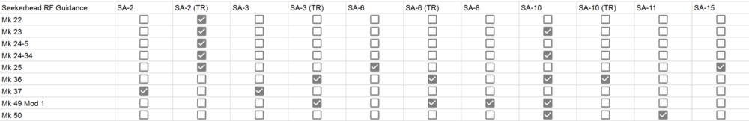
List of all radars in the game:
Unit name | F-4E RWR symbol | Seeker
SAM SA-2/3/5 P19 "Flat Face" SR
SAM SA-2 S-75 "Fan Song" TR
SAM SA-2 S-75 RD-75 Amazonka RF
SAM SA-3 S-125 "Low Blow" TR
SAM SA-5 S-200 "Square Pair" TR
SAM SA-5 S-200 ST-68U "Tin Shield" SR
SAM SA-6 Kub "Straight Flush" STR | 6??
SAM SA-8 Osa "Gecko" TEL | 8??
SAM SA-10 S-300 "Grumble" Big Bird SR
SAM SA-10 S-300 "Grumble" Clam Shell SR
SAM SA-10 S-300 "Grumble" Tin Shield SR
SAM SA-10 S-300 "Grumble" Flap Lid-A TR
SAM SA-10 S-300 "Grumble" Flap Lid-B TR
SAM SA-11 Buk "Gadfly" Fire Dome TEL
SAM SA-11 Buk "Gadfly" Snow Drift SR
SAM SA-13 Strela 10M3 "Gopher" TEL
SAM SA-15 Tor "Gauntlet"
SAM SA-19 Tunguska "Grison"
AAA Fire Can SON-9
SPAAA ZSU-23-4 Shilka "Gun Dish"
MCC-SR Sborka "Dog Ear" SR
EWR 1L13
EWR 55G6

From discord, not sure if correct:

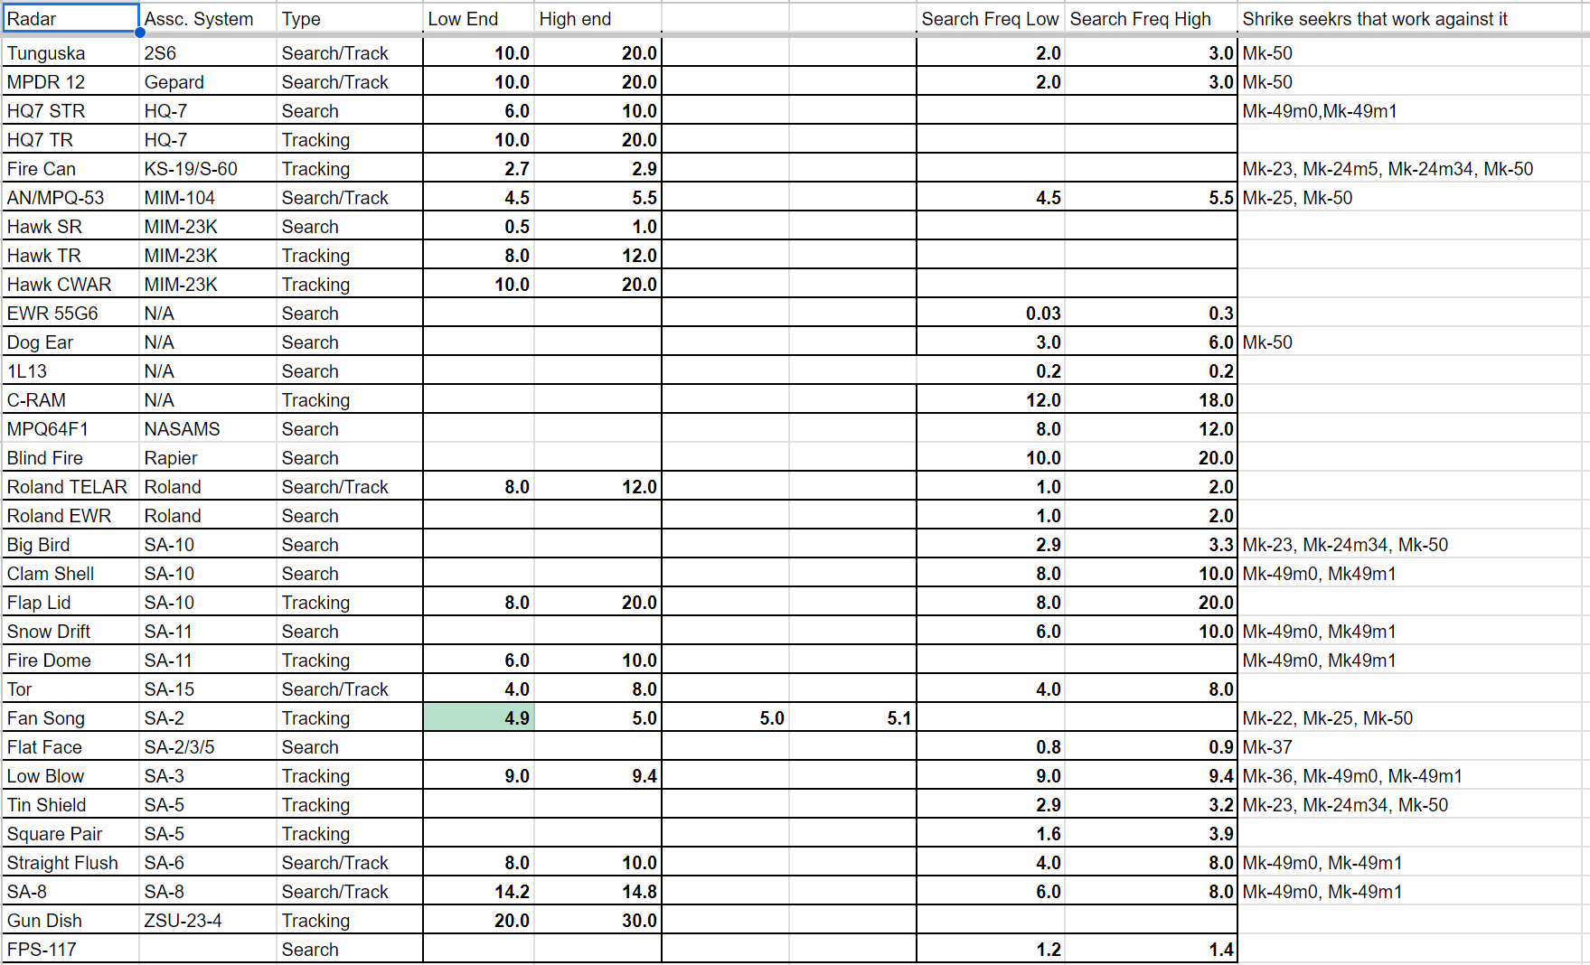
If correct, use the following:
Mk 49 Mod 0/1 | Mk 50
HQ-7 STR | 2S6
Clam Shell (SA-10) | Gepard
Snow Drift (SA-11) | Fire Can (S60)
Fire Dome (SA-11) | Patriot
Low Blow (SA-3) | Dog Ear
Straight Flush (SA-6) | Big Bird (SA-10)
SA-8 | Fan Song (SA-2)
 | Tin Shield (SA-5)

2S6, GepardFire Can (S60),

